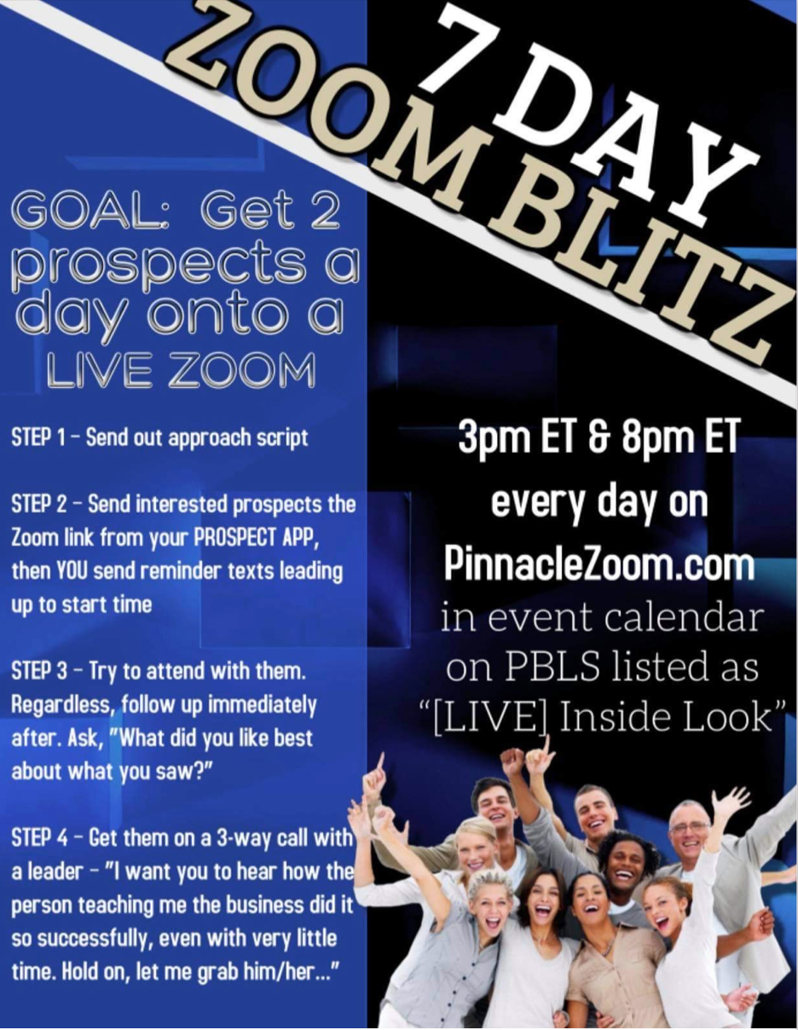
GOAL: Get 2 prospects a day onto a LIVE ZOOM

Step 1 – Send out approach script

Step 2 – Send interested prospects the Zoom link from your PROSPECT APP, then YOU send reminder texts leading up to start time

Step 3 – Try to attend with them. Even if you can’t, invite to it anyway! Follow up immediately after. Ask, “What did you like best about what you saw?”

Step 4 – Get them on a 3-way call with a leader – “I want you to hear how the person teaching me the business did it so successfully, even with very little time. Hold on, let me grab him/her...”

Use these scripts to call/text/private message your prospects:

APPROACH SCRIPT:

Hey Mary, just curious would you be open to checking out a great way to make some extra income using social media. No worries if not, just thought I would ask.
OR
Hey Mary, just curious are you open to side income projects if the money is exciting enough? No worries if not, just thought I would ask. I thought about you when they said they are looking to bring in more people.

When they say yes...

Perfect! In fact, what are you doing at 3pmET today? They are doing a live online overview to give you an inside look that will explain everything. If I can get you in, would you hop on to take a look?

When they say yes...

Ok great, I will get a link sent to you now. See you then. Text me when finished so I can show you how I’ve been doing it.

SENDING THE LINK:

Add prospect as a contact into your PROSPECT APP, then on their profile click EVENT INVITE, find the Zoom they want to attend called “[LIVE] Inside Look” at 3pmET or 8pmET, then it will give you options on how to send them the trackable invite link by text or email.

If 3pm doesn't work... Pivot to invite to to 8pm. – “It’s your lucky day, we had so many wanting to see this who also can’t do 3pm, so they are doing one more at 8pm. I might be able to get you in on that one. Can you make that work?”

If 8pm doesn't work, pivot to send them the PBO opportunity video link - “I don’t want you to totally miss out. If I can finagle getting you access to a replay of one they just did, what time could you spend 20 minutes to watch it later today?”

REWARDS:

EVERY DAY that you get TWO prospects to click a link sent from your PBLS app, you will be entered into the LegalShield company drawings for DAILY $100 prizes!

Keep track of your Zoom attendees by writing their names in the blanks on this sheet, submit at end of the blitz to your upline ExecDir.
Your upline Executive Director may also be running contests around this as well.

Anyone who gets 7 prospects to attend this week, you will get a drawing entry. Get 14 for the week, get THREE entries! (Shoot for 2/day, but the end total result is what we will count.) Brian Carruthers will do a special drawing for a private 30 minute 1:1 financial coaching session with him!

Monday
___________________________
___________________________

Tuesday
___________________________
___________________________

Wednesday
___________________________
___________________________

Thursday
___________________________
___________________________

Friday
___________________________
___________________________

Saturday
___________________________
___________________________

Sunday
___________________________
___________________________

